Personnel responsible:
- Material Handlers and Lead Operators in their absence

Safety equipment:
- All safety glasses and appropriate safety apparel is to be worn at all times.
- Typical Safety PPE for Acid Unloading – See Acid Unloading Procedure
- Before approaching the Tank Car or Truck containing Sulfuric Acid put on the following Personal Protective Equipment: Safety Goggles, Face Shield, Rain Suit, and Rubber Gloves
- The warning sign (blue) must be in place during unloading.
- Giles lock must be on track derail before hooking up cars.

Summary:
- This procedure describes the steps involved in and the responsibility of releasing and empty Acid Car.

Procedure:
- Follow Acid Unloading Procedure for handling Acid car – this Procedure is just for filling out the “Acid Car History Log”
  - When and Acid car is spotted by the rail road the Material Handler or designate is responsible for printing out a new Acid Car History Log for the car.
  - Each car gets its on log.
  - All appropriate information is to be filled in before unloading the car
    - The car number
    - Time spotted
    - Seal Number
  - The car can then be sampled, hooked up and dumped following the Acid Unloading procedure
  - If the operator is unable to finish dumping car during their shift, the next shift takes over on the log. Initialing beside each section they are responsible for.
    - Each section MUST be initialed by responsible person.
  - If there are issues with a car it is the responsibility of the Operator to fill out all information involved with the car. This will be the only record of problems or issues with this car.
  - Once the car is finished unloading and all appropriate measure have been made, the Material Handler or Lead Operator is to sign the log stating
“I have physically checked this acid car and placards.
I declare it empty and ready to return”
* When signing this statement Operators are taking responsibility for this car.
  - Operators are to notify Quality department that the car is ready and completed log is to be placed with all other completed shift work logs to be picked up and filled by Quality department.

SAMPLE LOG SHEET
Operator must initial each blank that they fill in.

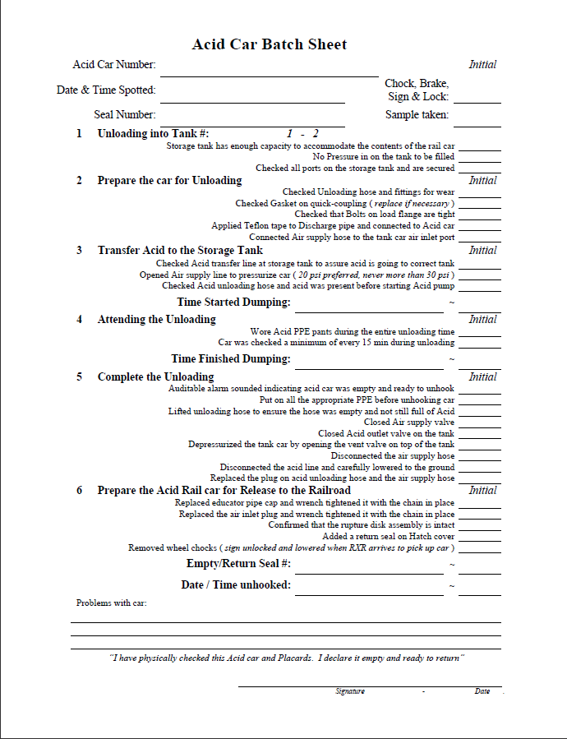
Write down any problems or issues you have with the car. This is the only way we can track car problems
When car is finished dumping, car is unhooked and placards checked Operator is to sign official release of the car.

This signature is stating Operator takes responsibility or ownership for releasing this car

TRAINING DOCUMENTATION

 | EMPLOYEE | TITLE | SIGNATURE | DATE
1
2
3
4
5
6
7
8
9
10
11
12
13
14
15
16
17
18
19
20
21
22
23
24
25

REVISION HISTORY
Revision Date | Revision Number | Revision Description
06/30/09 | 1 | Added the new Acid car Log sheet

